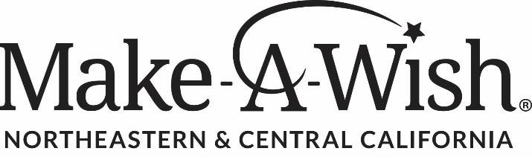

JOB TITLE: Director of Development

Job Summary:
The Director of Development is a dynamic leader responsible for overseeing a diverse portfolio of giving and has a proven track record of securing multi-year six figure gifts. They will have a natural ability to form strategic partnerships to generate new revenue streams and will work with the Senior Director of Chapter Advancement to lead the development and execution of a comprehensive fundraising strategy that drives sustainable revenue growth across individual giving, major gifts, corporate partnerships, grants, events, and peer-to-peer fundraising. Responsible for achieving annual revenue goals through pipeline development, donor acquisition and retention, strategic stewardship, and cross-functional collaboration. This role is a member of the development team and will be responsible for fundraising efforts across the chapter region, which includes Sacramento, the Northern State, and the Central Valley region. This role reports to the Senior Director of Chapter Advancement.

Key Responsibilities:

Fundraising Strategy & Donor Development
- Develop and implement strategies to identify, cultivate, solicit, and steward donors to meet revenue goals.
- Lead donor stewardship activities, focusing on cultivating and soliciting individual and major gifts.
- Manage and grow Make-A-Wish NCC’s monthly donor program and major gift initiatives.
- Implement and update fund development plans to attract new donors and enhance existing relationships. Develop customized giving opportunities aligned with organizational priorities and donor interests.
- Conduct prospect research to identify local, regional, and national grant opportunities.

Corporate & Foundation Partnerships
- Design and implement strategies to secure corporate sponsorships, cause-marketing partnerships, employee engagement programs, and corporate grants.
- Develop sponsorship packages and partnership proposals that maximize revenue and long-term engagement.
- Grow corporate partnership revenue through prospecting, renewals, upgrades, and strategic relationship management.
- Establish multi-year partnerships that support both fundraising and mission objectives.

Event Leadership
- Lead and execute fundraising events and secure corporate support and the cultivation of new opportunities.
- Oversee fundraising events from strategy through execution, ensuring strong revenue performance and donor engagement.
- Drive sponsorship sales, ticket revenue, auction performance, and mission integration.
- Leverage events as a pipeline-building tool for major gifts, corporate partnerships, and individual donor cultivation.

Digital Campaigns
- Oversee direct response, digital fundraising, and donor engagement campaigns that grow unrestricted revenue. Produce capacity-building and social network digital fundraising campaigns.

Community Engagement
- Act as a Make-A-Wish ambassador, building relationships with local leaders, organizations, and stakeholders to drive support and awareness.
- Represent Make-A-Wish in the media and at public events and community gatherings to enhance organizational reputation and visibility.

Revenue Management & Team Leadership
- Monitor and report progress against revenue goals, pipeline movement, and fundraising performance metrics.
- Lead and coach development staff to achieve individual and team fundraising objectives.
- Ensure fundraising activities align with organizational priorities, donor-centered best practices, and long-term sustainability goals.

Qualifications
- 5-7 years of progressive nonprofit fundraising experience, with a demonstrated track record of achieving and exceeding revenue goals across individual giving, major gifts, corporate partnerships, foundation grants, fundraising events, and peer-to-peer fundraising.
- Strong business development and relationship management skills, with demonstrated success cultivating and stewarding high-net-worth individuals, corporate partners, board members, and community stakeholders.
- Experience leading fundraising events and campaigns with responsibility for sponsorship development, participant engagement, donor cultivation, and revenue performance.
- Exceptional written, verbal, presentation, and interpersonal communication skills with the ability to effectively engage donors, volunteers, executive leadership, and community partners. Proficiency in Microsoft Office Suite, CRM systems, and donor database software such as Salesforce.
- Deep understanding of issues impacting children with critical illnesses and commitment to diversity, equity, and inclusion.

Education:

B.A./B.S. in a relevant field or equivalent work experience; advanced degree in nonprofit management, or a related field preferred.

Compensation:
This is a full-time position with a salary range: $75,000-$110,000 and commensurate with experience. Benefits include 401K, health, dental, and vision coverage and paid time off.

Work Environment:
This position is in the Sacramento office and may require occasional evening or weekend work and travel within the region.

This role is pivotal to achieving our ambitious short- and long-term revenue goals and is a unique opportunity to make a meaningful difference for children and families in our region.

