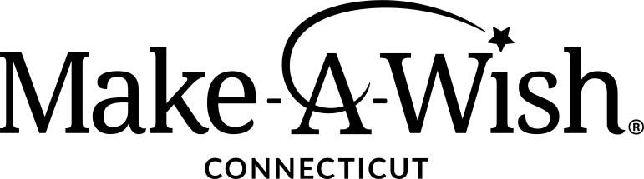

PHILANTHROPY MANAGER

Job Summary
The Philanthropy Manager is responsible for creating and executing fundraising strategies and campaigns to engage and upgrade mid-level donors. This person will be a pivotal member of the team and will help grow our development program through implementation of a Mid-Level Donor Program, grant funding, appeals and campaigns, and portfolio management.

The Successful Candidate
The ideal candidate will be able to build and maintain effective relationships both internally and externally. Outstanding communication and people skills are essential. A strong work ethic combined with honesty and integrity is an absolute requirement as is a dedication to the mission of Make-A-Wish. A collaborative style will result in a strong departmental and chapter structure, ensuring success for all. The successful candidate will be someone who enjoys a strong team environment. To be successful as a Philanthropy Manager, this person should be a motivated, goal-oriented professional who is passionate about acquiring new donors and deepening relationships with existing donors.

Position Responsibilities
- Solicit, secure, and steward chapter donors to achieve annual revenue goals.
- Identify new revenue opportunities and advance relationships through a portfolio of mid-level individual and corporate donors and prospects.
- Implement and manage annual grants cycle and create and share proposals with funders.

General
- Adhere to all Make-A-Wish America performance standards and Make-A-Wish Connecticut internal controls, policies, and procedures, including maintenance of the Salesforce database.
- Represent Make-A-Wish Connecticut at the required internal and external events.
- Foster a culture of cooperation and collaboration among the various departments of the chapter.
- Maintain transparent reporting, information and records that are commensurate with a first-class organization.
- Demonstrate commitment to personal growth and development of self and team.
- Perform other duties as assigned.

Knowledge, Skills, and Abilities Requirements
As with all members of Make-A-Wish Connecticut staff, the Philanthropy Manager must believe in the mission and vision of Make-A-Wish. They must model integrity, work to inspire colleagues and contacts, and strive to build a solid base of loyal donors. In addition, the Philanthropy Manager should:
- Have experience with portfolio management, lead generation, and a proven track record of setting and achieving revenue goals.
- Be a confident communicator who is comfortable engaging donors in a variety of ways.
- Possess an energetic, outgoing personality with a sense of humor.
- Be well organized, self-motivated and detail oriented.
- Have a collaborative work ethic with strong interpersonal and problem-solving skills.
- Possess high levels of integrity, trustworthiness, flexibility, compassion, and humor necessary to address the practicalities of a growing nonprofit, along with the creativity and persistence required to elicit new thinking and change.
- Be able to work with minimal supervision, to manage multiple priorities, and to work in a deadline and goal driven environment.
- Flexibility to work outside standard work hours and travel throughout the state.
- Must be proficient in Microsoft Office (Word, PowerPoint, Excel, Outlook).
- Experience with Salesforce a plus but not a requirement

About Us
Make-A-Wish believes that a wish experience can be a game-changer for a child with a life-threatening medical condition. This one belief guides us in everything we do. It inspires us to grant wishes that change the lives of the kids and families we serve.

Make-A-Wish Connecticut is part of the nation’s largest and most well-established wish granting organization, with chapters and volunteers throughout the U.S. and abroad. The work of Make-A-Wish is accomplished by a volunteer governing board of directors, a paid staff of dedicated employees, and hundreds of dedicated volunteers.

Our local staff is dedicated to creating life-changing wishes for children with critical illnesses. We are committed to maintaining the Foundation’s vision of reaching every eligible child and making his or her one true wish come true.

We respect and ensure equal opportunity, regardless of race, religion, ethnicity, national origin, age, gender identity, sexual orientation, disability, perceived disability, and other legally protected characteristics.

The Wishing Place
- This position is an on-site role at Make-A-Wish Connecticut’s Wishing Place in Trumbull, CT.
- On-site amenities include a half-court basketball court, putting green, walking track, interactive games, unlimited ice cream, decks overlooking the ponds, and regular opportunities to experience a wish firsthand.

