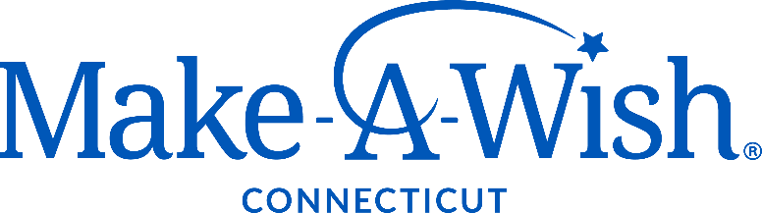

PHILANTHROPY DIRECTOR

Job Summary
The Philanthropy Director is responsible for executing a successful individual giving strategy focused on connecting the interests and passions of donors with organizational funding opportunities.

The Successful Candidate
The ideal candidate will be a development professional with demonstrated experience identifying, initiating, nurturing, and maintaining close relationships with major individual donors and donor prospects. They will have a passion for the mission of Make-A-Wish and possess imagination, vision, leadership, and integrity. To be successful, they will have broad knowledge of the principles of fundraising, including the ability to direct and participate in all aspects of the major gifts cycle.

Outstanding communication and interpersonal skills are essential. A strong work ethic combined with honesty and integrity is an absolute requirement, as is a dedication to the mission of Make-A-Wish. A collaborative style will result in a strong inter-departmental and Chapter structure, ensuring success for all. The successful candidate will be someone who enjoys a strong team environment.

Position Responsibilities
- Assume revenue responsibility for a $2M revenue budget consisting of major, planned, and individual gifts.
- Identify, engage, cultivate, solicit and steward current and prospective major donors.
- Develop and manage a portfolio of major donor prospects with a focus on securing gifts of over $10K, bringing new donors to the organization, and cultivating individuals to make transformative gifts (six and seven figure donations).
- Create and implement a robust system of moves management and stewardship.
- Manage and mentor the Philanthropy Manager to ensure all revenue goals and performance metrics are met.
- Act as a mentor to other staff members as appropriate to enhance their performance and professional development.
- Recommend objectives, policies, and plans for relevant business areas with senior leadership team.
- Adhere to all Make-A-Wish America performance standards and Make-A-Wish Connecticut internal controls, policies, and procedures.
- Represent Make-A-Wish Connecticut at the required internal events and as a spokesperson at external events.

Knowledge, Skills, and Abilities Requirements
As with all members of the Make-A-Wish Connecticut staff, the Philanthropy Director must believe in the mission and vision of Make-A-Wish, as well as the Association of Fundraising Professionals Code of Ethical Standards. They must model integrity, work to inspire colleagues and contacts, and strive to build a solid base of loyal donors. In addition, the Philanthropy Director should possess the following:
- Demonstrated success and expertise in major gifts fundraising (5+ years required).
- Proven record of securing major and leadership gifts.
- Prior experience supervising fundraising or sales staff.
- Experience in a team-based, cross-functional work environment with effective and respectful communication as a top priority.
- Sales focus with demonstrated success in building and nurturing relationships, developing and meeting strategic goals, prospecting, presentation skills, and driving results.
- High level of integrity, trustworthiness, flexibility, compassion, and humor necessary to address the practicalities of a growing non-profit, along with the creativity and persistence required to elicit new thinking and change.
- Be able to work with minimal supervision and manage multiple priorities in a deadline driven environment.
- Excellent written and verbal communication skills.
- Proficiency in Microsoft Office 365 and Salesforce or relationship management software.
- Expertise in fundraising best practices.
- Flexibility to work outside standard work hours.

About Us
Make-A-Wish believes that a wish experience can be a game-changer for a child with a life-threatening medical condition. This one belief guides us in everything we do. It inspires us to grant wishes that change the lives of the kids and families we serve.

Make-A-Wish Connecticut is part of the nation’s largest and most well-established wish granting organization, with chapters and volunteers throughout the U.S. and abroad. The work of Make-A-Wish is accomplished by a volunteer governing board of directors, a paid staff of dedicated employees, and hundreds of dedicated volunteers.

Our local staff is dedicated to creating life-changing wishes for children with critical illnesses. We are committed to maintaining the Foundation’s vision of reaching every eligible child and making his or her one true wish come true.

We respect and ensure equal opportunity, regardless of race, religion, ethnicity, national origin, age, gender identity, sexual orientation, disability, perceived disability, and other legally protected characteristics.

The Wishing Place
- This position is an on-site role at Make-A-Wish Connecticut’s Wishing Place in Trumbull, CT.
- On-site amenities include a half-court basketball court, putting green, walking track, interactive games, unlimited ice cream, decks overlooking the ponds, and regular opportunities to experience a wish firsthand.

