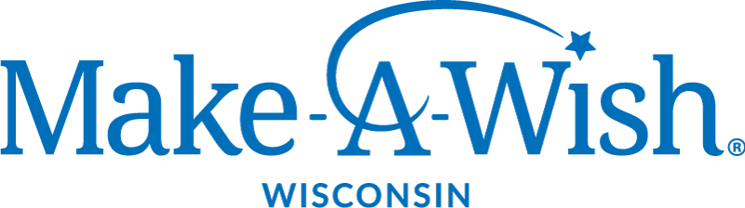

Opportunity Profile:
Madison Regional Director

“Together, we create life-changing wishes for children with critical illnesses.”

About Make-A-Wish
Chris Greicius, a 7-year-old boy from Phoenix, was diagnosed with leukemia in the spring of 1980. More than anything else, he wished to be a police officer. Caring people in his community granted his wish ... and set in motion a phenomenon that would create an unprecedented kind of charity: Make-A-Wish.

Today, chapters throughout the United States serve every community across the nation and its territories. Each has its own board of directors, staff and volunteers. Chapters are the force bringing the Make-A-Wish mission to life. For most wishes, it is local staff members and volunteers who meet Wish kids and their families, are told of the child’s one true wish, and devote their energy to make each wish come true. Make-A-Wish International, based in Phoenix along with the national office, is the hub for wish-granting activities in nearly 50 countries, outside of the United States, on five continents, and counting.

Since the founding of the Wisconsin chapter of Make-A-Wish in 1984, over 7,000 children and their families throughout the state have experienced the life-changing power of a wish. This year, Make-A- Wish® Wisconsin granted 396 wishes with a budget of over $8 million. More than 500 Wisconsin children will be diagnosed this year alone with a critical illness, qualifying them for a wish.

For more information:
https://wisconsin.wish.org/ https://www.guidestar.org/profile/39-1543541

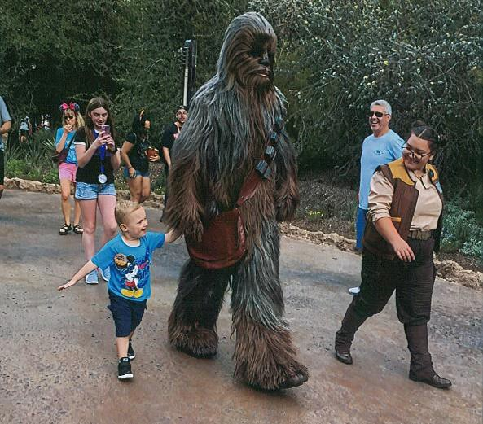
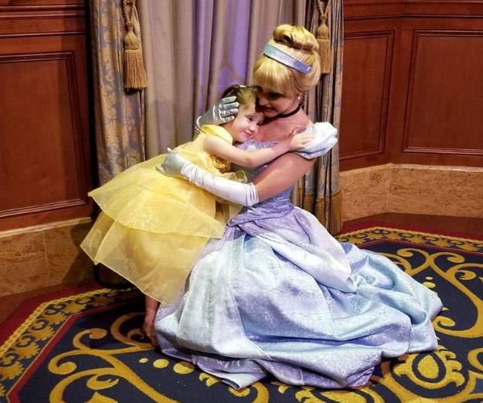

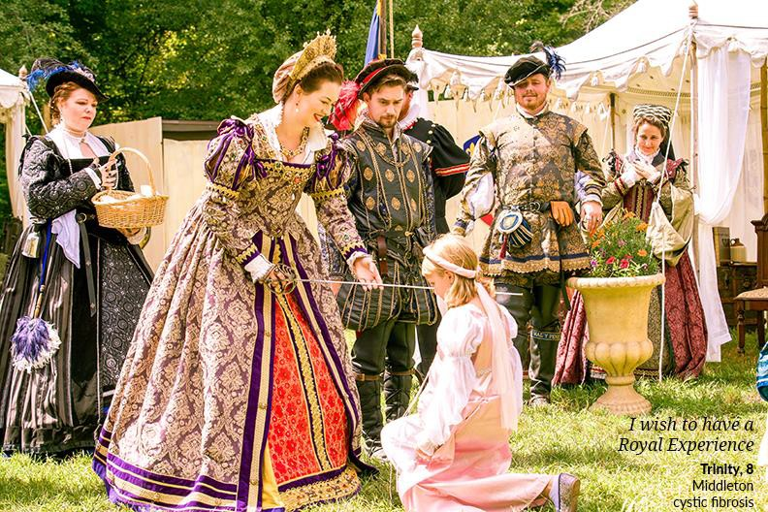

The Opportunity
The Madison Regional Director will be passionate about the Make-A-Wish mission, granting wishes to children with critical illnesses. They will have deep community ties to Madison and the surrounding area which they can leverage for the organization, and proven fund development expertise. They will be responsible for building financial support and community awareness for Make-A-Wish in Madison and the seven-county region; this will include individual giving, events, corporate sponsorships, and planned giving. The Madison Regional Director will serve as a leader in communicating the Make-A-Wish mission and vision to donors and community partners, working collaboratively with the regional leadership team which includes the chapter office in Milwaukee, and the Northeast Regional Office in Appleton. They will serve as the face of Make-A-Wish in the region, building and maintaining relationships with local board members and community partners, including American Family Children’s Hospital.

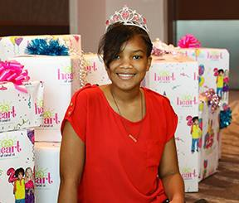
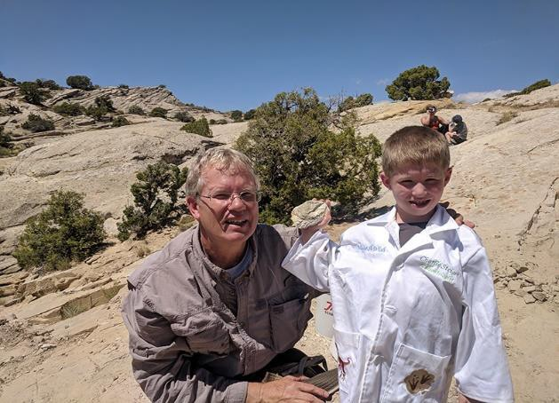

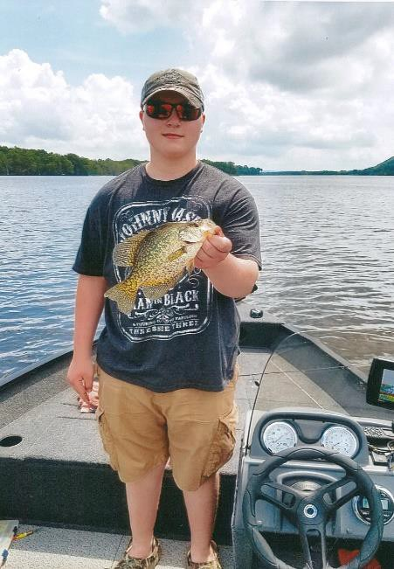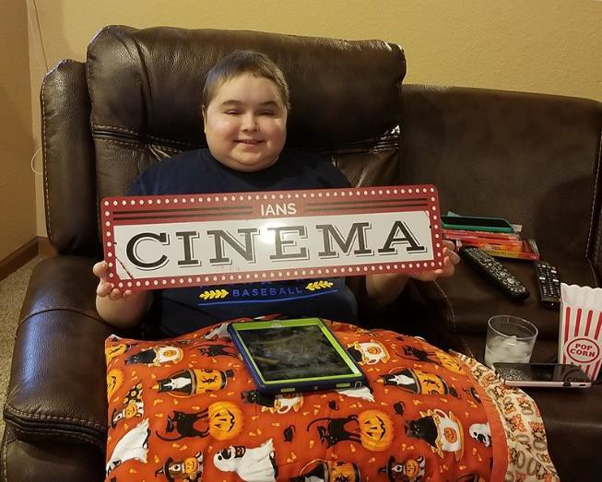

Essential Job Duties and Responsibilities
- Serve as lead fundraiser: proactively establish and implement a comprehensive fundraising program to drive growth, ensuring a stable financial base in Madison and the surrounding area.

- Work collaboratively with other offices on individual and corporate solicitations, major gifts, grants, sponsorships, events and workplace giving as needed. Manage national fundraising relationships in the area with the chapter office.

- Proactively develop effective individual, foundation and corporate relationships to achieve results by identifying opportunities, researching prospects, building and maintaining donor recognition and relationships, and ensuring donor engagement, retention, and satisfaction.

- Build appropriate partnerships with Board leadership, committees, staff, volunteers, Wish families, community partners, and the public to accomplish financial goals.

- Be accountable for the successful creation, implementation, and completion of internal special events in the territory to maximize outcomes for all stakeholders.

- Establish and manage Madison Advisory Council, a young professionals’ group, and event committees in the region for various events that may be held in the area.

- Manage regional office operations, including internal controls, budgeting, financial accountability, compliance to national performance standards and ensure sound business practices and fiscal responsibility.

- Serve as the face of the organization in Madison, representing Make-A-Wish Wisconsin at events and speaking engagements as appropriate. Help develop communications efforts within the region, in coordination with chapter-wide efforts.

- Work to more fully engage current and future board members in the Madison area, in partnership with the Milwaukee staff and board.

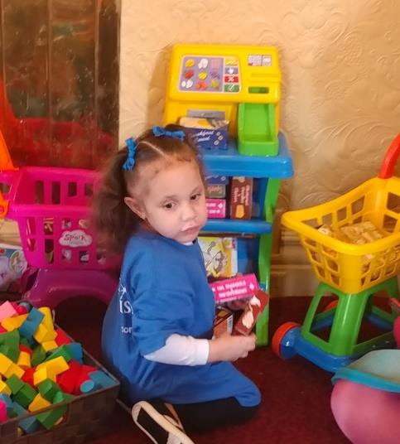

Skills, Qualifications, and Experience
- Self-motivated, goal and detail-oriented professional with a BA/BS Degree in Non-profit Management/Fundraising, Marketing, Business, or similar background, and five years of progressive professional experience in managing and directing a successful fund development program.
- Collaborative work style, passion for the Make-A-Wish® mission, and high integrity; able to interact with diverse groups of people and motivate and inspire others to achieve results.
- Knowledge of the Madison/South Central philanthropic communities required. Must demonstrate ability to network and develop strong relationships, manage multiple priorities within tight timelines, and effectively set/manage priorities as needed.
- Previous experience working with a Board of Directors and committees desired. An understanding of how to build and maintain an effective board, how to best communicate with them collectively and as individuals, and how to utilize the board’s skill sets to benefit the mission of Make-A-Wish.
- Exceptional written, verbal and interpersonal skills, strategic thinking, and budget management.

- Demonstrated success in securing grants and major gifts, and an understanding of the complex nature and time frame of the development effort, including experience with the innovative ways to fundraise among new revenue sources and donor partners.

- Comfortable serving as the face of Make-A-Wish in Madison and surrounding communities, speaking in public forums and with the media.

- Prior experience working in a health care-based nonprofit desired.
- Computer literacy in Microsoft Office Suite; Raiser’s Edge and/or Salesforce experience
preferred.
- Willingness to work evening and weekend hours as needed.

Job Location
Madison anchors a thriving economic region of 536,000 and is regarded as one of the best places in America to live, work, and play. Madison is a rare combination of thriving businesses, progressive government, rich culture and advanced education - all in a setting of rare natural beauty. Surrounded by five lakes, Madison is home to one of the best networks of biking trails in the US, distinctive locally- owned businesses, safe neighborhoods, excellent healthcare, green resources, superior public education, unique music venues and a burgeoning restaurant scene. thriving locavore restaurant, brewery, and distillery scene. With a comparatively low unemployment rate, and a 15-minute commute downtown from most surrounding communities, Madison offers a high quality of life.
Madison, Wisconsin consistently earns top results in nationwide quality-of-life rankings, articles and surveys. For more information, please visit:
http://www.visitmadison.com/
http://greatermadisonchamber.com/ https://fundreds.com/wisconsin/things-to-do-in-madison
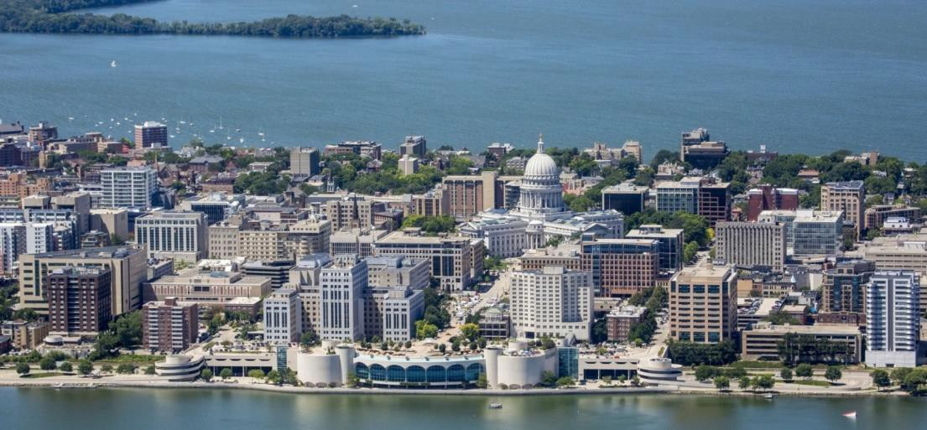

Application and Selection Process
Make-A-Wish Foundation of Wisconsin has exclusively retained The QTI Group to conduct the search for its new Madison Regional Director. The QTI Group is a comprehensive human resources advisory

services firm founded in 1957. QTI is headquartered in Madison, Wisconsin and has nine branch offices throughout the state of Wisconsin, including Appleton.

Qualified individuals interested in being considered for the position are invited to submit their resume together to: https://tinyurl.com/s5brbco
Inquiries may be submitted to The QTI Group at the email address or phone number listed below.

Jennifer Winding, Executive Search Director Trisha Campbell, Recruiting Consultant 1010 East Wisconsin Avenue, Suite 314
Madison, WI 53703
608-257-1057
Jennifer.winding@qtigroup.com or Trisha.Campbell@qtigroup.com

